# Introduction to GPTs and Programming Landscape

What are Generative Pre-trained Transformers (GPTs)? In this first part, we will go over the basics:

* + Definitions
  + How GPTs work
  + Evolution of GPTs
  + How to build your own GPT

Let’s start with a bit of theory. I’ll take as assumption that the reader has a basic mathematic or scientific education, with notions of programming. I will not go deep into the different dimensions of Artificial Intelligence and Machine Learning. I’ll simply provide the necessary background to apply AI to your concrete applications.

## Definitions

### What the GPT acronym stands for

GPTs (**Generative Pre-Trained Transformers**) are a family of AI models that can perform tasks such as generating natural language from a query (also called a prompt).

GPTs are a type of **generative** models, which means that they can create new data from existing data. For example, given an image, a generative model can produce another image that is similar but not identical to the original one. Similarly, given a text, a generative model can produce another text that is related but not identical to the original one.





They have been **pre-trained** on massive amounts of text from the internet and can produce coherent and diverse responses on almost any topic. They can also perform various tasks, such as answering questions, summarizing texts, generating images, and more.



GPTs use a special kind of model called a **transformer**. A transformer is a neural network that can learn to map any input sequence to any output sequence. For example, given a sentence in English, a transformer can learn to translate it to French.

### Key concepts

A transformer consists of two parts: an **encoder** and a **decoder[1]**. The encoder takes the input sequence and transforms it into a vector representation, which captures the meaning and context of the input. The decoder takes the vector representation and generates the output sequence.

**Self-Attention** is a key ingredient of the transformer architecture. This has been introduced in 2017, in a paper called *“Attention is all you need”*[2]. The attention layer provides **contextual understanding.** It enables the model to consider the context of each word in a sentence, regardless of its position. This means each word's representation is influenced by every other word in the sentence, allowing for a more nuanced understanding of language. This provides efficiency in processing. Unlike recurrent neural networks (RNNs), self-attention processes all words in a sentence simultaneously, leading to significant gains in computational efficiency.

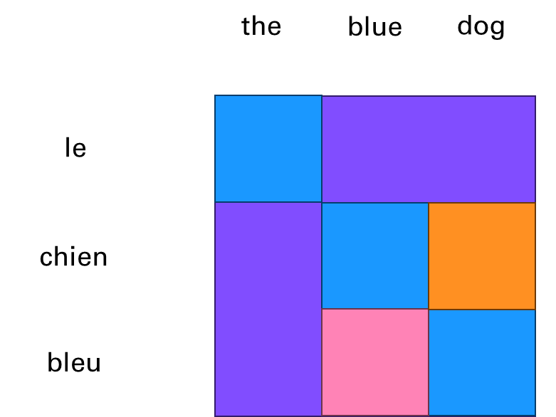

**Large Language Models** (LLM) are the main type of Generative Pre-trained Transformers, that have been popularized by ChatGPT. They operate word by word, based on the probability of each word being the most likely next word. This property is called autoregressive.

* It means that, given the input "How are you", an LLM might generate the output "I am fine, thank you".
* To generate the first word, it uses only the input. To generate the second word, it uses the input and the first word.
* To generate the third word, it uses the input, the first word, and the second word, and so on.

This way, an LLM can generate coherent and fluent texts, by learning from the patterns and structures of natural language. Here is an example with the motto of MathWorks: Accelerating the pace of …

If you want to go deeper into the inner workings of LLMs, I recommend the book Natural Language Processing with Transformers[3].

## How LLMs Work

The process of building a Generative Pretrained Transformer requires the following steps:

* **Training Data:** LLMs are trained on vast amounts of text data. This data helps the model learn language patterns, grammar, and information about the world.
* **Learning Process:** During training, AI models use supervised learning by simply comparing pairs of inputs and outputs with what the networks predict from the input alone. And it corrects the internal parameters accordingly to fit the training set. LLMs are using the attention mechanism to weigh the importance of each word in a sentence relative to the others. This process helps the model understand context and relationships between words.
* **Language Modeling:** The primary task during training is language modeling, where the model learns to predict the probability of a word given the preceding words. This process is what makes the model generative.
* **Tokenization:** Text input is broken down into tokens (which can be words or parts of words) before being fed into the model. The model then processes these tokens through its layers to generate predictions.
* **Output Generation:** When generating text, the model uses its learned probabilities to select the most likely next word. This process continues, generating text one word at a time until a stopping condition is met (like reaching a maximum length or generating a specific token).

## Evolution of GPTs

### Life BC (Before ChatGPT)

One of the first GPT models was GPT-1, which was released in 2018 by OpenAI. It had 117 million parameters, which are the numbers that determine how the model processes the input and output. GPT-1 was trained on a large corpus of text from the Web, called WebText, which contained about 40 GB of data. GPT-1 showed impressive results in generating realistic and diverse texts, as well as performing well on several natural language tasks, such as summarization, translation, and question answering.

However, GPT-1 also had some limitations. For example, it could not handle long-term dependencies, which means that it could not remember or use information that appeared earlier in the text. It also struggled with factual consistency, which means that it could not verify or correct the information that it generated. Moreover, it sometimes produced offensive or biased texts, which reflected the quality and diversity of the data that it was trained on.

To address these issues, OpenAI released GPT-2 in 2019, which was a much larger and more powerful version of GPT-1. It had 1.5 billion parameters, which was more than 10 times the size of GPT-1. It was also trained on a much larger corpus of text, called WebText2, which contained about 570 GB of data. GPT-2 improved significantly on the performance and quality of GPT-1, and achieved state-of-the-art results on many natural language benchmarks. It also demonstrated a remarkable ability to generate coherent and engaging texts on a variety of topics and styles, such as news articles, essays, stories, and reviews.

However, GPT-2 also raised some ethical and social concerns. Due to its high level of realism and versatility, GPT-2 could potentially be used for malicious purposes, such as spreading misinformation, impersonating others, or generating fake content. Therefore, OpenAI decided to release GPT-2 gradually, starting with a smaller version of 124 million parameters, and then releasing larger versions over time, along with some tools and guidelines to help researchers and developers use GPT-2 responsibly and safely.

The latest and most advanced GPT model is GPT-3, which was released in 2020 by OpenAI. It is the largest and most complex language model ever created, with a staggering 175 billion parameters, which is more than 100 times the size of GPT-2. It was also trained on an enormous corpus of text, called WebText3, which contained about 45 TB of data. GPT-3 surpassed GPT-2 in every aspect, and achieved unprecedented results on a wide range of natural language tasks, such as reading comprehension, text classification, sentiment analysis, and semantic search. It also demonstrated a remarkable ability to generate high-quality and diverse texts on almost any topic and style, such as poetry, lyrics, recipes, jokes, and dialogues.

GPT-3 is not only a powerful language generator, but also a general-purpose artificial intelligence system, that can learn to perform any task that can be described in natural language. For example, given a prompt like "Write a summary of this article", or "Create a slogan for this company", or "Solve this math problem", GPT-3 can generate appropriate and accurate responses, by using its vast knowledge and understanding of language and the world.

One of the key features of GPT-3 was its ability to perform tasks with little to no task-specific training, known as **zero-shot** or **few-shot learning**. This means it could understand and respond to prompts in a meaningful way, even if it hadn't been explicitly trained on that task.

GPT-3.5, also known as ChatGPT, is an improved version of GPT-3, that focuses on enhancing its conversational skills. ChatGPT is designed to be a friendly and engaging chatbot, that can chat with humans about any topic, and provide relevant and interesting information and jokes.

### AI Alignment

ChatGPT is based on the same architecture and data as GPT-3, but with some key differences. The main issue that it is “fixing” is what is called alignment[4]. Alignment is the process of encoding human values and goals into large language models to make them as helpful, safe, and reliable as possible. Essentially it builds guardrails so that the AI doesn’t embed the biases that can be found in some places of the internet.

**How did OpenAI achieve this?**

ChatGPT was initially meant only as a research project to demonstrate the potential of **Reinforcement Learning from Human Feedback**. This was leveraging some of the early work of OpenAI in the field of Reinforcement Learning that is often associated with robotics or games like chess, go or playing mario.

In traditional Reinforcement Learning, an agent learns to make decisions by interacting with an environment to maximize cumulative reward. The agent explores actions, observes results, and receives rewards or penalties, which guide future actions.

In RLHF, human feedback supplements or replaces the predefined reward signals. Human evaluators observe the agent's actions and provide feedback on their quality or appropriateness. This feedback helps shape the reward function.

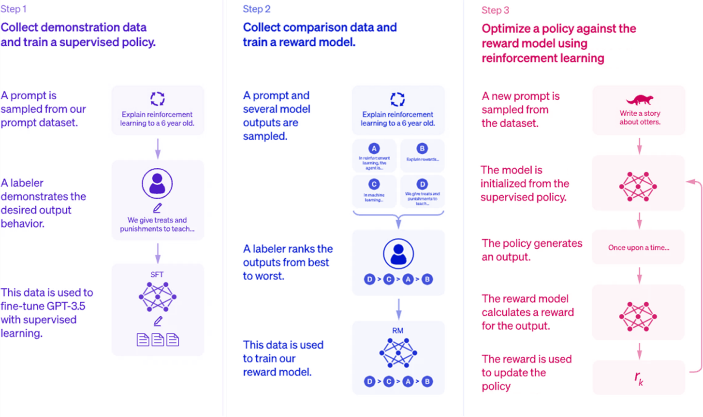

Here are the steps explained for the alignment of ChatGPT through reinforcement:

* **Step 1:** *Collect demonstration data and train a supervised policy*  
  Human feedback is used to label the training data. This is used to fine-tune the model.
* **Step 2:** *Collect comparison data and train a reward model*  
  Humans are rating the output of the model from the previous step. This is captured in a reward function.
* **Step 3:** *Optimize a policy against the reward model*  
  This is now an iterative process without manual human input where the two previous steps are brought together to improve alignment.

## How to build your own GPT

When OpenAI coined the term GPT, they offered a low-code approach to building your own GPT (by programming without coding). This book offers an alternative for programming GPTs that offers richer options (as described in the table below). A strong ecosystem boomed in 2023 from this rich set of options around different opiniated approaches to tackle this challenge.

Here is a high-level table[5] that compares what can be done via the ChatGPT app vs the API:

|  |  |  |
| --- | --- | --- |
|  | **ChatGPT App** | **ChatGPT API** |
| **Creation Process** | No code | Requires coding for integration |
| **Operational Environment** | Located in ChatGPT | Can be integrated into any product or service |
| **Pricing** | Included in ChatGPT on Plus/Team/Enterprise plans | Billed based on usage of different Assistant features |
| **User Interface** | Built-in UI with ChatGPT | Designed for programmatic use; can use playground for visualization |
| **Shareability** | Built-in ability to share GPT with others | No built-in shareability |
| **Hosting** | GPTs hosted by OpenAI | OpenAI does not host Assistants |
| **Tools** | Built-in tools like:  Browsing, DALL·E, Code Interpreter, Retrieval, and Custom Actions. | Built-in tools like:  Code Interpreter, Retrieval, and Function calling. |

Some very clever programmers[6] even go so far as to build such elaborate AI models from scratch, or based on open-source implementations such as the Llama family of models (from Meta). This isn’t the approach taken in this book as it is way more involved and requires very deep AI and programming skills.

In this book, we will adopt an approach in between the “low-code” and “high-code” to build your own AI-powered applications. For this we will just get the right level of understanding of how those GPTs are operating by familiarizing ourselves with the ChatGPT Application Programming Interface (API).

To explain the need for the API, you can consider the cases of using vs building AI-powered products.

This is really well explained in a video about Generative AI in a nutshell[7].

1. Encoder-decoder architecture: Overview <https://www.youtube.com/watch?v=zbdong_h-x4>
2. Attention is all you need: <https://arxiv.org/abs/1706.03762>
3. <https://transformersbook.com/>
4. <https://research.ibm.com/blog/what-is-alignment-ai>
5. GPTs vs Assistants <https://help.openai.com/en/articles/8673914-gpts-vs-assistants>
6. Andrej Karpathy - Let's build GPT: from scratch, in code, spelled out. <https://www.youtube.com/watch?v=kCc8FmEb1nY>
7. Generative AI in a nutshell: <https://www.youtube.com/watch?v=2IK3DFHRFfw>